Essence of Man

God The Father

Access to God
John 14.6, Eph. 2.18
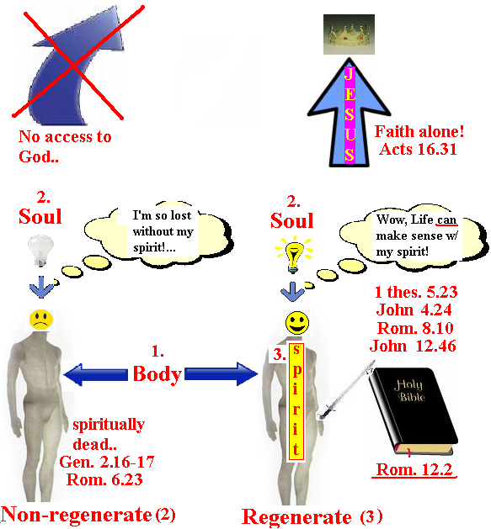
( Body & Soul) (Body, Soul, and Spirit)

