JOSHUA
CHAPTER 14
LESSON #89 (9-23-12)

- Verses 1-5 See the Map.
- The tribe of Levi was not granted any specific land parcel.
3. Ruben forfeited his double portion and it went to Joseph’s two sons, Manasseh and Ephraim.
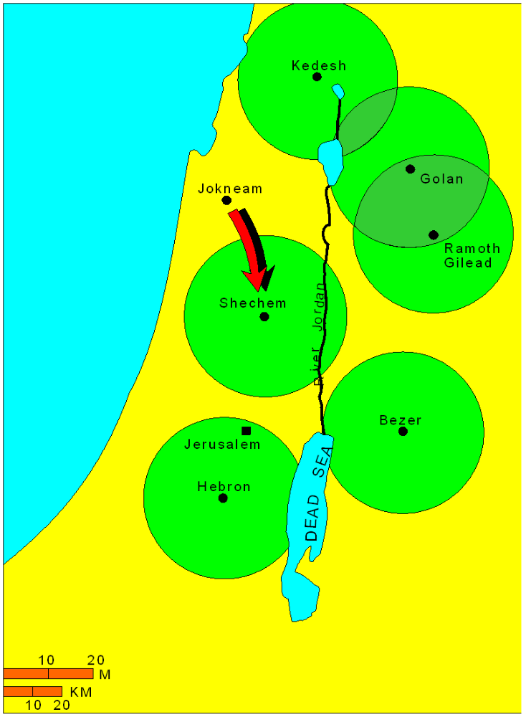

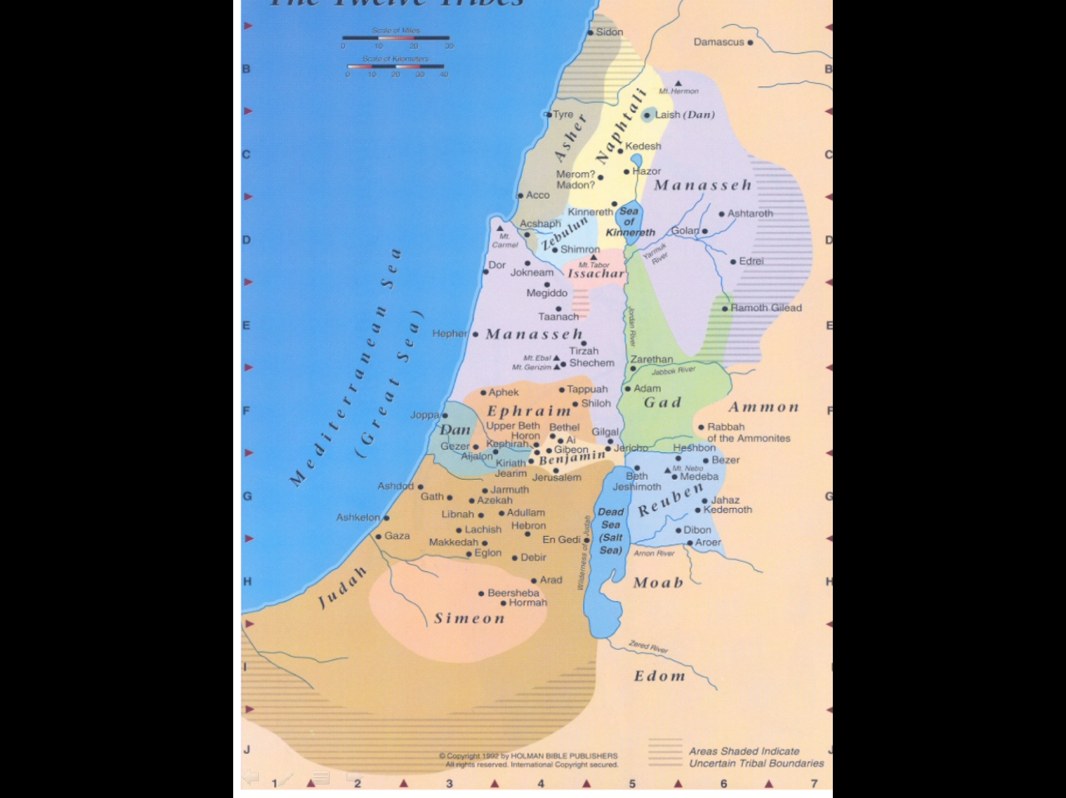
Some of the Cities of Refuge

Interesting fact: Ruben was the first born to Jacob/Israel and would have gotten the double portion of inheritance but he had sex with one of his father’s concubines and forfeited his inheritance, Gen. 49:3-4; 35:22.

Now after more than four centuries the punishment for Reuben’s sinful act was passed on to his descendants because he was the head of his tribe. His actions affected all who came after him. Who does this remind you of? This person sinned and the punishment was passed on to the entire human race.

Romans 5:12 Therefore, just as through one man [Adam] sin entered into the world, and death through sin, and so death spread to all men, because all sinned . . .

Why is this important? It allowed God to impute all our personal sins to Christ on the cross. He was condemned for our sins. If we were not condemned for Adam’s original sin, we would be condemned for our sins and we would be no salvation.
JOSH 14, pg 2
These first five verses are typical of Hebrew writers. The overall picture is given in summary form and then the details follow. This explains the structure of Genesis. Genesis 1-2:3 is a summary of creation; Genesis 2:4 and following has to do with the details; there is no conflict between Genesis chapter 1 and Genesis chapter 2 if you understand Hebrew style. Newspapers have a similar style. They give an overview right away and then fill in the details.

LESSON #90 (9-30-12)

Verse 1 Notice that it was not just Joshua that was to distribute the land but also Eleazar the high priest. The heads of the households would take reception of the land parcels.

Num. 27:18-19 “And the LORD said unto Moses, take thee Joshua, the son of Nun, a man in whom is the Sprit, and lay thine hand upon him.”

Now this is said forty or fifty years before the passage we’re studying tonight.

Verse 19 “And set him before Eleazar, the priest, and before all the congregation, and give him a charge in their sight.”

Verse 2 “And he shall stand before Eleazar, the priest, who shall ask counsel for him after the judgment of Urim before the LORD; at his word shall they go out, and at his word they shall come in, both he, and all the children of Israel with him, even all the congregation.”

There was something supernatural going on by which God was able to guide on a "YES" or "NO" basis. This is not prophecy; the prophets gave verbal revelation. This is just a yes/no type revelation through the devices of Urim and Thummim which were stones that may have lit up in answer on the high priests' vesture. Apparently this is what Joshua would use to get the Lord's perfect plans as to how to parcel out the land. I also eliminated any quarreling since the Lord himself decided the boundaries between them. The point to remember is that Joshua followed the protocol God had established exactly to the letter.

He did the right thing in a right way.

So a change takes place here, when Moses died there would no longer be a man who has direct access to God. Therefore Joshua must approach God through the high priest who has the Urim and the Thummim.

Throughout the next several chapters you are going to get very specific detail regarding the land that each tribe would inherit. Why all the excruciating detail? It underscores the importance of inheritance and it demonstrates the faithfulness of God in keeping his promises. Why all the

Another reason for the precise details of parceling out these pieces of real estate is found in:

Leviticus 25:23-25 The land, moreover, shall not be sold permanently, for the land is Mine; for you are but aliens and sojourners with Me. 24) 'Thus for every piece of your property, you are to provide for the redemption of the land. 25) 'If a fellow countryman of yours becomes so poor he has to sell part of his property, then his nearest kinsman is to come and buy back what his relative has sold. 26) Or in case a man has no kinsman, but so recovers his means as to find sufficient for its redemption, 27) then he shall calculate the years since its sale and refund the balance to the man to whom he sold it, and so return to his property. 28) 'But if he has not found sufficient means to get it back for himself, then what he has sold shall remain in the hands of its purchaser until the year of jubilee; but at the jubilee it shall revert . . .

If any Israelites down through history lost control of that land through bad business deals, on the 50th year of Jubilee, this land would revert back to the family who originally had title to it. So for example, if this land had been used as collateral for a loan, and the loan fell through and somebody seized this land to pay for the loan, the land ultimately would have to go back to that person who originally had title to it and these chapters in Joshua established original ownership.

JOSH 14, pg 3 Ownership of land is sacred. Property taxes and inheritance taxes are an abomination !

LESSON #91 (10-7-12)

Here is something else to consider. Heb. 9:15 speaks of an eternal inheritance for believers in Christ. Joshua had to conquer the land in order for the tribes to be able to inherit it. Jesus had to conquer death by going to the cross, dying in our place, and rising again in order for us to be able to receive our eternal inheritance designed just for us.

1 Peter 1:3-5 Blessed be the God and Father of our Lord Jesus Christ, who according to His great mercy has caused us to be born again to a living hope through the resurrection of Jesus Christ from the dead, 4) to obtain an inheritance which is imperishable and undefiled and will not fade away, reserved in heaven for you, 5) who are protected by the power of God through faith for a salvation ready to be revealed in the last time.

imperishable means that it is impossible for our inheritance to perish away. It won’t burn up, depreciate through inflation, be stolen, nor can we ever lose it once it is given to us.

undefiled means it cannot be diminished, tinkered with, reduced, weakened, or taxed. It is untouched by the pollution of this world.

will not fade away . . . is the best part. There is no time limit, it lasts forever!

Parents and grandparents spend a lot of time and effort to leave their children and grandchildren an inheritance that is perishable, can be corrupted, ruined, or defiled, and one that will fade away. It’s a shame that they put little time if any in teaching them about the eternal inheritance Peter and the writer of Hebrews wrote about.

The decisions we believers make now to grow up in grace and knowledge of Jesus Christ and our resultant service to the Lord or the lack of these determines who we will be and what we will have for all eternity !

Revelation 14:13 And I heard a voice from heaven, saying, "Write, 'Blessed are the dead who die in the Lord from now on!'" "Yes," says the Spirit, "that they may rest from their labors, for their deeds follow with them."

What does this mean? We create our own personal historical record of service to the Lord and it follows us to heaven.

Ephesians 1:11-14 . . . also we have obtained an inheritance [api], having been predestined [ap,pt] according to His purpose who works all things after the counsel of His will, 12) to the end that we who were the first to hope in Christ should be to the praise of His glory. 13) In Him, you also, after listening to the message of truth, the gospel of your salvation... having also believed, you were sealed [api] in Him with the Holy Spirit of promise, 14) who is given as a pledge of our inheritance, with a view to the redemption of God's own possession, to the praise of His glory. (See Visual: )

How does predestination fit in here? Think about it. How is the inheritance allocated in the Old Testament? It is allocated by God’s sovereign will, they had to consult the Urim and the Thummim; the tribes have no say what the exact nature of their inheritance is going to be; so the exact nature of our inheritance is planned for us in predestination, verse 11.

The ministry of the Holy Spirit in our lives and the effects He produces in your life are an earnest or foretaste of what this future inheritance is going to be like. The fruit of the Spirit that the H.S. produces in us now is a small preview of what lies ahead in eternity which will be greatly magnified.
When we are walking in the power of the Spirit we are actually getting a fore taste of heaven. When we are thinking divine viewpoint and applying doctrine, we are securing our eternal inheritance.

JOSH 14, pg 4
Galatians 5:22-23 But the fruit of the Spirit is love, joy, peace, patience, kindness, goodness, faithfulness, 23) gentleness, self-control; against such things there is no law.

Does every believer automatically receive an inheritance ?

Romans 8:16-17 The Spirit Himself bears witness with our spirit that we are children of God, 17) and if children, heirs also, heirs of God and fellow heirs with Christ, if indeed we suffer with Him in order that we may also be glorified with Him.

LESSON #92 (10-21-12)

We’ve seen the importance God places on parents being able to pass down their land as an inheritance to their children. By way of comparison, what do we have today?

Some of you are renters and some of you own property.

How many children have lost the inheritance their parents desired to leave them because their property had to be sold in order to pay inheritance tax?

Most parents are very diligent in doing the best they can to leave an inheritance for their children. Nothing wrong with that, but that inheritance is only temporary and must be maintained. How many parents have taught their children about the eternal inheritance that is available to them?

God was very specific about the details of the inheritance the Israelites were to receive in the land of Canaan. Wouldn’t He give even more attention to the details of our eternal inheritance?

Heb. 9:15 speaks of an eternal inheritance for believers in Jesus Christ. Joshua had to conquer the land in order for the tribes to be able to inherit it. Jesus had to conquer death by going to the cross, dying in our place, and rising again in order for us to receive the eternal inheritance custom-designed just for us. There are two types of inheritance for the believer.

ETERNAL INHERITANCE #1 that every believer receives the moment each believes in J.C. is guaranteed from that point onwards.

Titus 3:5-7 He saved us, not on the basis of deeds which we have done in righteousness, but according to His mercy, by the washing of regeneration and renewing by the Holy Spirit, 6) whom He poured out upon us richly through Jesus Christ our Savior, 7) so that being justified by His grace we would be made heirs according to the hope of eternal life.

Hebrews 1:14 Are they not all ministering spirits, sent out to render service for the sake of those who will inherit salvation?

Ephesians 1:11-14 . . . also we have obtained an inheritance [api], having been predestined [ap,pt] according to His purpose who works all things after the counsel of His will, 12) to the end that we who were the first to hope in Christ should be to the praise of His glory. 13) In Him, you also, after listening to the message of truth, the gospel of your salvation... having also believed, you were sealed [api] in Him with the Holy Spirit of promise, 14) who is given as a pledge of our inheritance, with a view to the redemption of God's own possession, to the praise of His glory.

How does predestination fit in here? Think about it. How was inheritance allocated in the Old Testa-ment? It was allocated by God’s sovereign will through consulting the Urim and Thummim. The tribes had no say in what the exact nature of their inheritance would be. Likewise, the exact nature of our inheritance is also planned in advance for us in predestination, verse 11.

The ministry of the Holy Spirit in our lives and the effects He produces in our lives are an “earnest” or foretaste of what our future inheritance is going to be like. The fruit of the Spirit that the H.S.
produces in us now is a small preview of what lies ahead in eternity which will be greatly magnified.
JOSH 14, pg 5
When we are walking in the power of the Spirit, we are actually getting a foretaste of heaven. When we are thinking divine viewpoint and applying doctrine, we are securing our eternal inheritance.
The second one is only a potential, it depends on the attitude of the believer towards God and His Word after salvation.

1 Peter 1:3-5 Blessed (ευλογητοs) be the God and Father of our Lord Jesus Christ, who according to His great mercy has caused us to be born again to a living hope through the resurrection of Jesus Christ from the dead, 4) to obtain an inheritance which is imperishable and undefiled and will not fade away, reserved in heaven for you, 5) who are protected by the power of God through faith for a salvation ready to be revealed in the last time.

imperishable means that it is impossible for our inheritance to perish away. It won’t burn up, depreciate through inflation, be stolen, nor can we ever lose it once it is given to us.
undefiled means it cannot be diminished, tinkered with, reduced, weakened, or taxed, and it will forever be untouched by the pollution of this world.
will not fade away is the best part. There is no time limit, it lasts forever! Parents and grandparents spend a lot of time and effort in order to leave their children and grandchildren an inheritance, but it is one that is perishable, can be corrupted, ruined, defiled, stolen, and will eventually fade away. It’s a shame that they invest little time teaching them about the eternal inheritance Peter wrote about.

Romans 8:16-17 The Spirit Himself testifies with our spirit that we are children of God, 17) and if children, heirs also, heirs of God and fellow heirs with Christ, if indeed we suffer with Him so that we may also be glorified with Him.

Colossians 3:23-24 Whatever you do, do your work heartily, as for the Lord rather than for men, 24) knowing that from the Lord you will receive the reward of the inheritance. It is the Lord Christ whom you serve.

LESSON #93 (10-28-12)

Hebrews 6:10-12 For God is not unjust so as to forget your work and the love which you have shown toward His name, in having ministered and in still ministering to the saints. 11) And we desire that each one of you show the same diligence so as to realize the full assurance of hope until the end, 12) so that you will not be sluggish, but imitators of those who through faith and patience inherit the promises.

John 12:26 If [^{3rd} class] anyone serves Me, he must follow Me; and where I am, there My servant will be also; if [^{3rd} class] anyone serves Me, the Father will honor him [rewards and decorations will be part of his inheritance].

2 Timothy 2:12 If we endure, we will also reign with Him; If we [will] deny Him, He also will deny us [our inheritance, rewards];

The decisions we believers make now to grow up in grace and knowledge of our Lord Jesus Christ and resultant service to Him or the lack of doing these will determine who we’ll be and what we’ll have for all eternity !

Revelation 14:13 And I heard a voice from heaven, saying, "Write, 'Blessed are the dead who die in the Lord from now on!'" "Yes," says the Spirit, "that they may rest from their labors, for their deeds follow with them."

What does this mean? We create our own personal historical record of service to the Lord and it follows us to heaven.

1 Corinthians 6:9-10 Or do you not know that the unrighteous will not inherit the kingdom of God? Do not be deceived; neither fornicators, nor idolaters, nor adulterers, nor effeminate,
JOSH 14, pg 6
nor homosexuals, 10) nor thieves, nor the covetous, nor drunkards, nor revilers, nor swindlers, will inherit the kingdom of God.

Galatians 5:19-21 Now the deeds of the flesh are evident, which are: immorality, impurity, sensuality, 20) idolatry, sorcery, enmities, strife, jealousy, outbursts of anger, disputes, dissensions, factions, 21) envying, drunkenness, carousing, and things like these, of which I forewarn you, just as I have forewarned you, that those who practice such things will not inherit the kingdom of God.

LESSON #94 (11-4-12)

Verse 6-9

“Caleb is introduced in this passage as the son of Jephunneh the Kenizzite. V 1, p 357

“According to Genesis 15:19 the Kenizzites were a tribe of Canaan in Abraham’s day. Caleb’s family then was originally outside the covenant and commonwealth of Israel as were Heber the Kenite (Jud. 4:17), Ruth the Moabitess (Ruth 1:1-5), Uriah the Hittite (2 Sam. 11:3, 6, 24), and others. It is apparent that the Kenizzites in part at least joined the tribe of Judah before the Exodus. So their faith was not hereditary but was the fruit of conviction. And Caleb displayed that faith throughout his long lifetime.”
Walvoord, J. F., Zuck, R. B., & Dallas Theological Seminary. (1985). The Bible Knowledge Commentary: An Exposition of the Scriptures (Jos 14:6–9)

So, 1) He wasn’t born an Israelite
2) His name meant “dog”
3. He was old, 85

Did any of that matter to him? Absolutely not!

“Age is strictly a case of mind over matter. If you don’t mind, it doesn’t matter.”
Jack Benny, quoted in New York Times

“The young have aspirations that never come to pass, the old have reminiscences of what never happened.” Saki, Reginald

Job 12:12 Wisdom is with aged men, with long life is understanding.

“In 1982, at least fifty thousand Americans entered into marriage in which one partner was sixty-five or older.” 1000 illustrations for preaching and teaching

He was alive and vibrant, he had tremendous character and tenacity. He is a good example that Bible doctrine never gets old or stale for those with positive volition.

GROWING OLD

“Nobody grows old by merely living a number of years. People grow old only by deserting their ideals. Years may wrinkle the skin, but to give up interest wrinkles the soul. Worry, doubt, self-distrust, fear and despair … these are the long, long years that bow the head and turn the growing spirit back to dust.

“Whatever your years, there is in every being’s heart the love of wonder, the undaunted challenge of events, the unfailing, childlike appetite for ’what next, ’ and the joy and the game of life.

“You are as young as your faith, as old as your doubt; as young as your self-confidence, as old as your fear; as young as your hope, as old as your despair.” —Douglas MacArthur

JOSH 14, pg 7
John Wesley traveled 250 miles a day for forty years, preached forty thousand sermons, produced four hundred books, and knew ten languages. At eighty-three, he was annoyed that he could not write more than fifteen hours a day without hurting his eyes, and at eighty-sixk he was ashamed he could not preach more than twice a day. He complained in his diary that there was an increasing tendency to lie in bed until 5:30 in the morning.
Moses was 80 when God called him; and although he cited many excuses, he never mentioned his old age.
Socrates gave the world his wisest philosophy at 70, and at an extreme old age, learned to play on musical instruments.
Plato was only a student at 50. He did his best after reaching 60.
Michelangelo was still composing poetry and designing structures in his 89th year. He painted the ceiling of Sistine Chapel on his back on a scaffold at near 90.
4034 Musicians, Artists, Theologians
Strauss was still composing serious music after his 80th birthday.
Verdi at 74 produced his masterpiece “Othello”, at 80 “Falstaff”, and at 85 the famous “Ave Maria”, “Stabat Mater” and “Te Deum”.
Titian completed his painting “Last Supper” when he was 80, and kept on painting for years. At 98, he painted his historic “Battle of Lepanto”.
Tintoretto at 74 painted the vast “Paradise”, a canvas 74 feet by 30.
Phillips Brooks, one of the world’s greatest preachers, was a powerful figure at 84.
4035 Politicians, Scientists, Businessmen
Gladstone was still a potential figure in political and intellectual circles when he was 80. He took up a new language at 70.
Bacon was a writer at 60 before he wrote his greatest works.
Milton completed Paradise Lost when 57 and Paradise Regained at 63.
Tennyson published “Crossing the Bar” at 83.
Daniel Auber wrote his “Dream of Love” in his 80s and said: “I’m not 80. I am four times 20.”
Ogilvie translated Homer and Virgil, was unacquainted with Latin and Greek until he was past 50.
Von Goethe wrote a part of Faust at 60 and finished it at 82.
Kent wrote his Anthropology, Metaphysics of Ethics, and Strife of the Faculties at age 74.
Oliver Wendell Holmes at 79 wrote Over the Teacups.
Victor Hugo wrote Les Miserables at 62.
Booth Tarkington wrote sixteen novels after age 60, some of them when he was totally blind.
George Bernard Shaw wrote some of his famous plays at 80.
Scott the commentator began study of Hebrew at 87.
Santayana, the great Harvard philosopher, continued to write books at 88 years of age.
Tennyson at 83 wrote “Crossing the Bar”.
Webster wrote his monumental dictionary at 70.
The Arkansas Baptist

“You Tell Me I’m Getting Old”

You tell me I am getting old;
I tell you that’s not so;
The “house” I live in is worn out
And that, of course, I know,

It’s been in use a long, long while,
It’s weathered many a gale;
I’m really not surprised you think
It’s getting somewhat frail.

The color’s changing on the roof,
The windows getting dim,
The walls a bit transparent,
And looking rather thin.

The foundation’s not so steady
As once it used to be;
My “house” is getting shaky,
But my “house” isn’t me!

My few short years can’t make me old.
I feel I’m in my youth,
Eternity lies just ahead,
A life of joy and truth,

I’m going to live forever, there;
Life will go on—it’s grand!
You tell me I am getting old?
You just don’t understand!

JOSH 14, pg 8
The dweller in my little “house”
Is young and bright and gay,
Just starting on a life to last
Throughout eternal day.

You only see the outside,
Which is all that most folks see.
You tell me I am getting old?
You’ve mixed my “house” with me!

LESSON #95 (11-11-12) Brief Review ~ Dora Johnson ~

Numbers 13:27, Deut. 1:27-40

Joshua 14:10-12 “Caleb did not retire at 65. Medical science has found that people who have been active all their lives and who suddenly retire with nothing to occupy their time and energy do not live long. A medical doctor told me that when people stop using their minds, they become senile and soon die. Caleb did not have a rocking chair mentality. In that sense, at least, I share Caleb’s spirit. Often I have said that when I die, I hope I am so busy for the Lord that I will run a block before I fall!”
Hobbs, H. H. (1990). My favorite illustrations (166). Nashville

Moses was 120 when he died and he retained his good eyesight and vigor, Deut. 34:7. What a great role model. Caleb had the same courage, drive, and optimism that he had 45 years earlier, vs. 11-12. No doubt, it was God’s promise of reward that kept him stable, energized, and full of hope the 40 years in the wilderness and the 5 years of war in Canaan.

God’s promise of reward helped Caleb and it can help us as well. He wanted Hebron [means communion], and he didn’t care if giants still lived there. God promised him that land and he knew God would drive them out before him. God didn’t keep him alive for 45 years just to allow him to die before receiving his reward.

Verse 8, 9, 14; Deut. 1:36
Caleb followed the Lord fully his entire life and he was still vigorous at 85 and was rewarded with a city of his choosing. It is faithfulness and consistency that impress God, not emotions or devotion that runs hot and then cold.

“Friend, someday we will be rewarded. We will not be rewarded according to the great amount of work done for God, nor according to our prominence and popularity. The important thing will be, “did you wholly [consistently] follow the Lord? Oh, that God’s people would learn today that the most important thing in this life is to wholly follow the Lord!”
Through the Bible With Vernon MaGee

Let’s look at a few N.T. verses that focus on following the Lord fully:

1 Timothy 4:6-8 . . . in pointing out these things to the brethren, you will be a good servant of Christ Jesus, constantly nourished [v. ppp] on the words of the faith [intake] and of the sound doctrine which you have been following [per. tense] [application].
But have nothing to do with worldly fables fit only for old women. On the other hand, discipline yourself for the purpose of godliness; for bodily exercise profits a little, but godliness is profitable for all things, having promise of the life that now is and of that which is to come.

JOSH 14, pg 9
discipline yourself, GUMNAZO (γυμνάζω) v. pam; to train, undergo discipline,
exercise, same as above only in the noun form.

Godliness, EUSEBEIA; EU, good + SEBEIA, respect = awesome respect accorded to God; devoutness, reverance, or a good respectful attitude towards God.

EUSEBEIA, godliness requires GUMNAZO discipline

LESSON #96 (11-25-12)

Two things that demand constant care in this life are the body and the spirit. If we neglect either one, we’ll have big time trouble. Both take daily maintenance. We need to be disciplined in what we eat and how we exercise our bodies.

We also need to be disciplined in what goes into our souls [intake of sound doctrine] and how we exercise our spirits [application of doctrine].

You’re doing the first part right now [intake]; maybe you’ll do the other part [application] later. Both take discipline.

NASV 1 Timothy 4:15-16 Take pains with these things [doctrines]; be absorbed in them, so that your progress will be evident to all. 16) Pay close attention to yourself and to your teaching; persevere in these things, for as you do this, you will ensure salvation both for yourself and for those who hear [pt. pa] you.

NKJV 1 Timothy 4:15-16 Meditate on these things; give yourself entirely to them, that your progress may be evident to all. 16) Take heed to yourself and to the doctrine. Continue in them, for in doing this, you will save both yourself and those who hear [pt. pa] you.

NIV 1 Timothy 4:15-16 Be diligent in these matters; give yourself wholly to them, so that everyone may see your progress. 16) Watch your life and doctrine closely. Persevere in them, because if you do, you will save both yourself and your hearers [pt. pa].

Vs. 15 NASV Take pains; NKJV Meditate on; NIV Be diligent; MELETAO (μελεταω) v. pam; to improve by diligent care.

Vs. 15 NASV be absorbed; NKJV give yourself entirely; NKJV give yourself wholly; EIMI (ειμι) v. pam; to be in close connection with.

Vs. 16 NASV Pay close attention; NKJV take heed, Watch; EPECHO (επεχω) v. pam; to maintain a grasp on someone or something; to be mindful or especially observant, persevering in the acknowledgement and practice of Christian doctrine. Zodhiates, S. (2000). The Complete Word Study Dictionary: New Testament

Vs. 16 NASV persevere; NKJV Continue in; EPIMENO (επιμενω) v. pam; to continue in an activity or state; persist (in) or persevere.

Tan, P. L. (1996). Encyclopedia of 7700 Illustrations: Signs of the Times. Garland, TX: Bible Communications, Inc.

